Link for the CV

Link for the publication

Research t Research Topic

Engineering the surface waves

In our team, we are engineering the propagation of surface waves (like surface-plasmon-polaritons) on the metamaterials, metasurfaces and novel 2D materials. Full control on the surface waves, will pave the road for the nano-devices in the near future. For the experiment, we employ scattering-type of the scanning near-field optical microscopy (s-SNOM). After many years of optical spectroscopy with a spatial resolution limited to the diffraction limit, s-SNOM makes it possible to reach 20-30nanometer resolution independent of the radiation source, i.e. from the microwave (λ=30 cm) tovisible (λ=530 cm) radiation. This novel microscope is based on an atomic force microscopy (AFM) setup. In the AFM technique, by employing a sharp metallic or dielectric tip (tip apex: 20-30 nanometer) we are able to obtain a topographical picture of the sample’s surface with nanometer resolution.



Near-field observation of guided-mode resonances on a metasurface via dielectric nanosphere excitation, 2018, submitted.

Amin Soltani, Dr. rer. nat.

Soltani@physik.uni-frankfurt.de

Tel +49 (0)69 798 47220

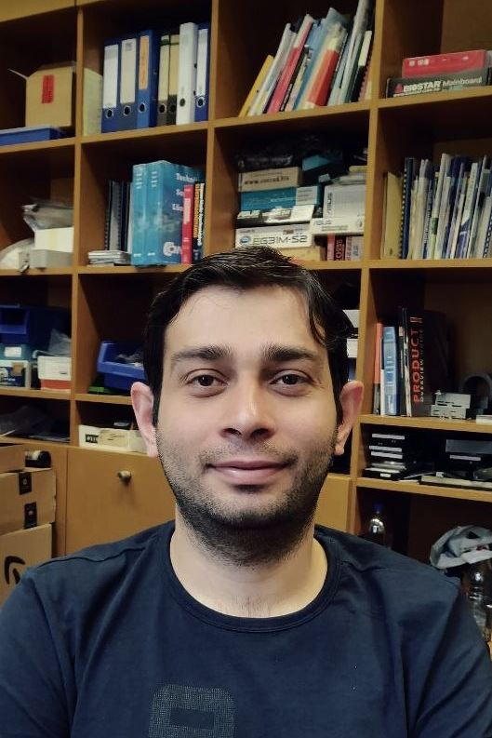hoto